Experiment-23
Write a LEX program to identify the capital words from the given input. Code:
%{
#include <stdio.h>
%}
%%
[A-Z]+ { printf("Capital Word: %s\n", yytext); }
.|\n ;
%%
int main(){ yylex(); return 0; } int yywrap(){ return 1; }
Output:
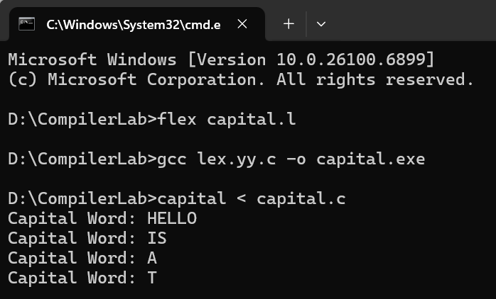

Experiment-24
Write a LEX Program to check the email address is valid or not. Code:
%{
#include <stdio.h>
%}
%%
[a-zA-Z0-9._%+-]+@[a-zA-Z0-9.-]+\.[a-zA-Z]{2,} { printf("Valid Email: %s\n", yytext); } [^\n]+ { printf("Invalid Email: %s\n", yytext); }
\n ;
%%
int main(){ yylex(); return 0; } int yywrap(){ return 1; }
Output:
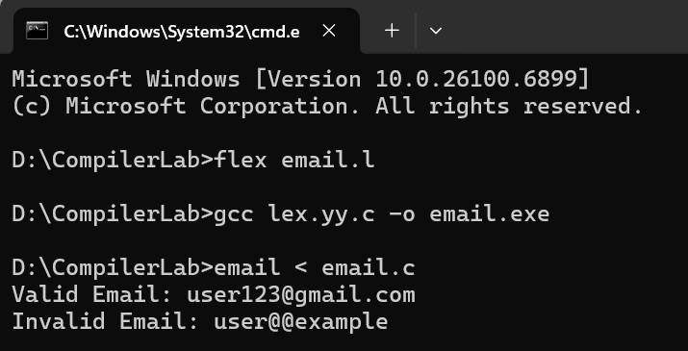

Experiment-25
Write a LEX Program to convert the substring abc to ABC from the given input string.
Code:
%{
#include <stdio.h>
%}

%%
abc { printf("ABC"); }
.|\n { ECHO; }
%%
int main(){ yylex(); return 0; } int yywrap(){ return 1; }
Output:
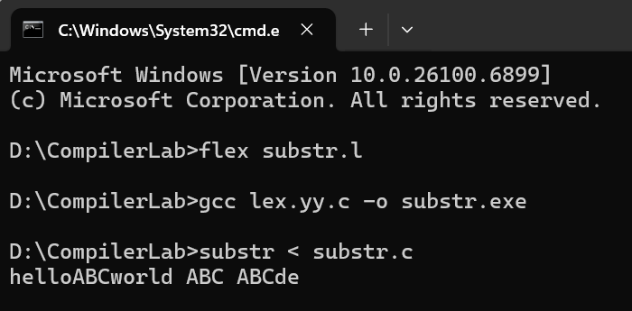

Experiment-26
The Organization manager had all the mobile numbers of employees. Assume that you are the manager and need to verify the valid mobile numbers because there may be some invalid numbers present. Implement a LEX program to check whether the mobile number is valid or not.
Code:
%{
#include <stdio.h>
%}
%%
(91)?[6-9][0-9]{9} { printf("Valid Mobile Number: %s\n", yytext); } [0-9]+ { printf("Invalid Mobile Number: %s\n", yytext); }
.|\n ;
%%

int main(){ yylex(); return 0; } int yywrap(){ return 1; }
Output:
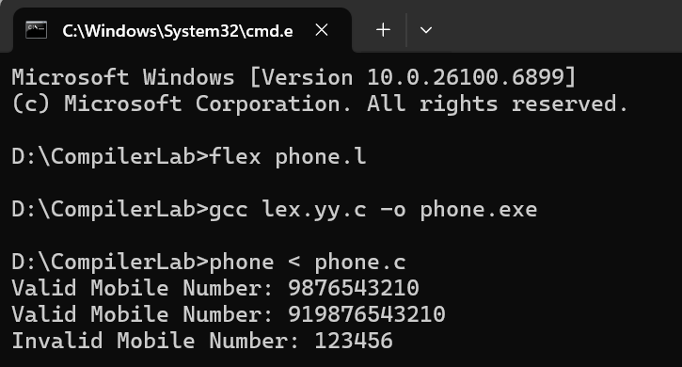

Experiment-27
Implement Lexical Analyzer using LEX or FLEX (Fast Lexical Analyzer). The program should separate the tokens in the given C program and display with appropriate caption.
Code:
%{
#include <stdio.h>
%}
IDENT [a-zA-Z_][a-zA-Z0-9_]* NUM [0-9]+
HEADER \<[a-zA-Z0-9._/]+\>
%%
{HEADER} { printf("Header: %s\n", yytext); } "int"|"void"|"return"|"printf"|"scanf"|"main" { printf("Keyword: %s\n", yytext); }
{IDENT} { printf("Identifier: %s\n", yytext); }

{NUM} { printf("Number: %s\n", yytext); }
\"([^\\\"]|\\.)*\" { printf("String: %s\n", yytext); }
[+\-*/=;,\(\)\{\}] { printf("Symbol: %s\n", yytext); } [ \t\n]+ ;
. ;
%%
int main(){ yylex(); return 0; } int yywrap(){ return 1; }
Input:
#include<stdio.h> void main(){
int a,b,c=30; printf("hello");
